2020-0701 IST 707 Data Analytics

Homework #6

Sathish Kumar Rajendiran

2020-08-28

Table of Contents

Task Summary 2

Dataset Preparation 3

Decision Trees (DT) 8

Supply Vector Machine (SVM) 12

Naïve Bayes 15

k-Nearest Neighbors (kNN) 16

Random Forest 17

Summary 18

Conclusion 18

## **Task Summary**

The data set comes from the Kaggle Digit Recognizer competition. The goal is to recognize digits 0 to 9 in handwriting images. Images are 28 *28 pixel with total of 784 pixels. It’s an integer value ranges between 0 to 255. Objective is to predict the handwritten images correctly by label using various supervised machine learning models (naïve Bayes decision tree, kNN, SVM and Random Forest). In addition, tune their parameters to get the best model (measured by cross validation) and compare which algorithms provide better model for this task. For more, refer to <https://www.kaggle.com/c/digit-recognizer/data>

1. Dataset Preparation
   1. Data extraction & Split train & test dataset
   2. Principal Component Analysis (PCA)
2. Build Decision Tree model
   1. Run decision tree models with and without PCA
3. Build k-Nearest Neighbors (kNN) model
   1. Build and Predict using kNN model
4. Build Supply Vector Machine (SVM) model
   1. Run with linear, radial and polynomial kernel settings
5. Build Naïve Bayes model
   1. Build and Predict using naive Bayes model
6. Random Forest
   1. Build and Predict using Random forest model
7. Summary
   1. Summarize and compare the models

## **Dataset Preparation**

In order to build the classifier models, first step is to understand the data and prepare training and test data sets. It involves the following steps,

* 1. Data extraction - import necessary packages for data extraction.

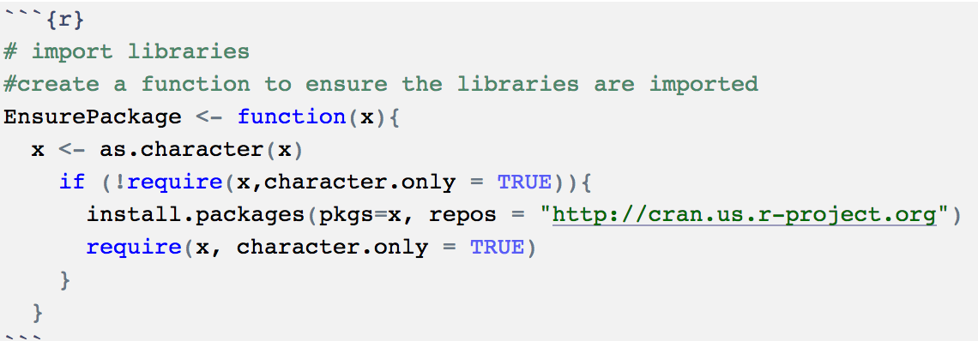

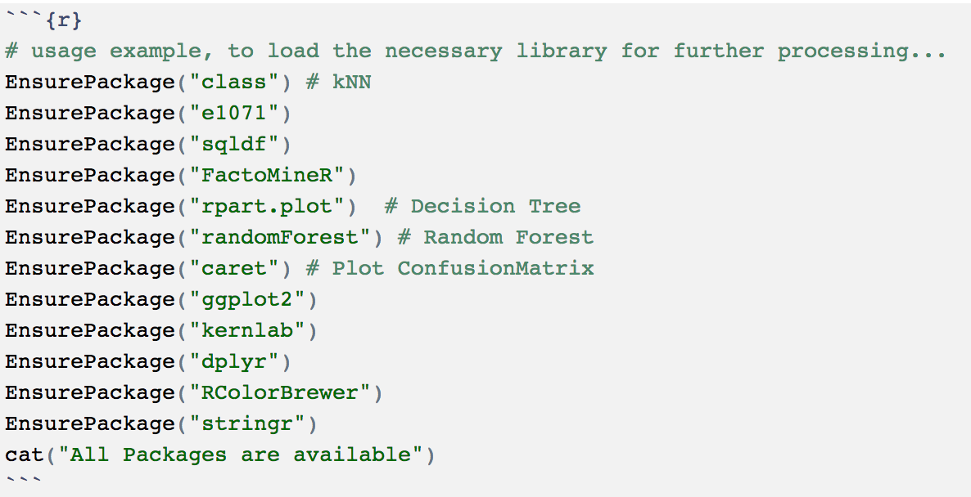

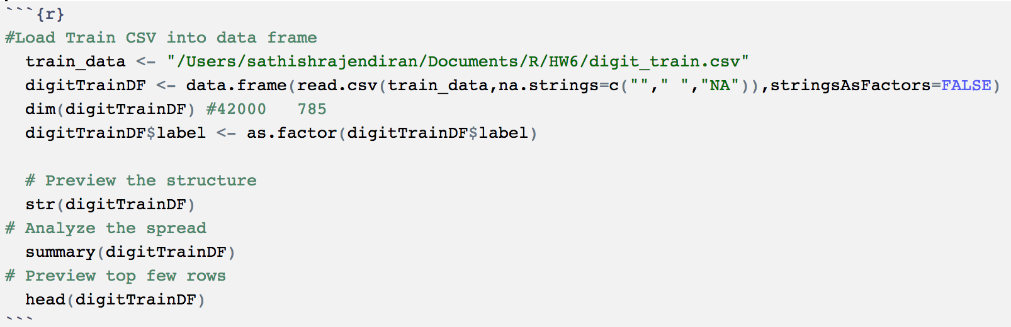

Training data has 42,000 rows ,784 predictor variables and 1 dependent variable (label) columns. Change the first column (label) as factor and make sure the remaining columns are numeric.

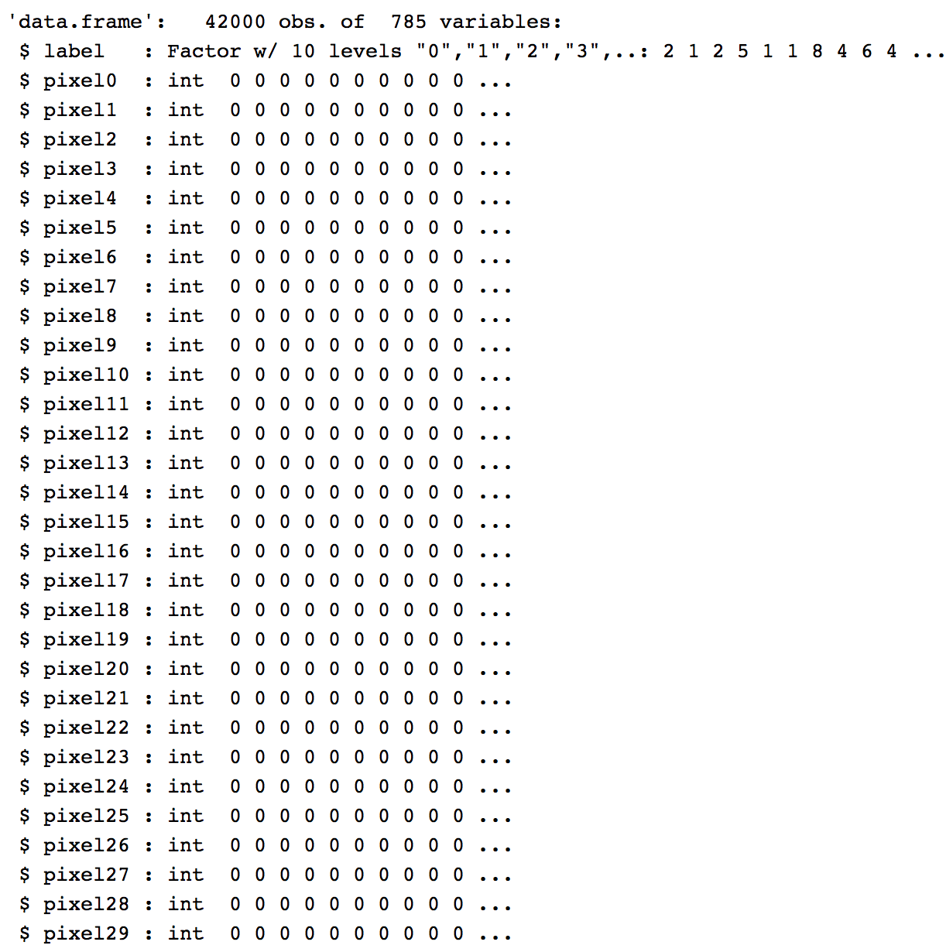

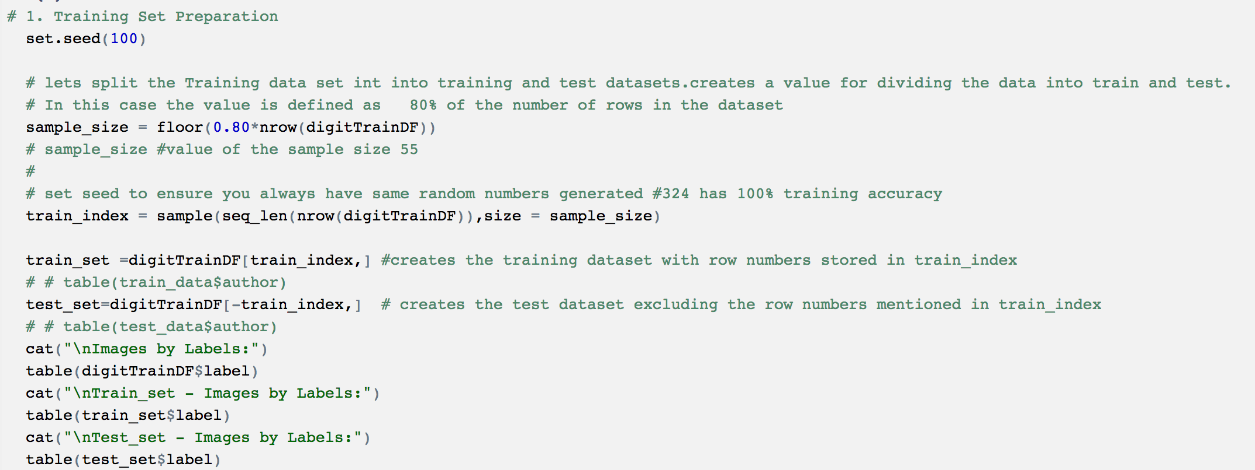

Let’s split the Training data into train_set and test_set with 80:20 split.

Train_set: 33600 rows and 785 column including label

Test_set: 8400 rows and 785 columns including label

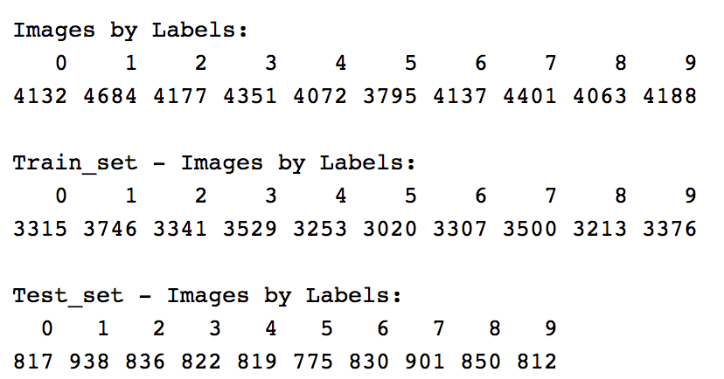

Preview and datatype of the dataset below,

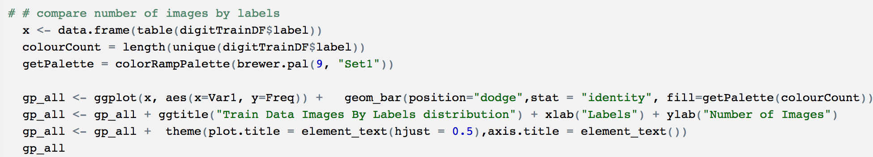

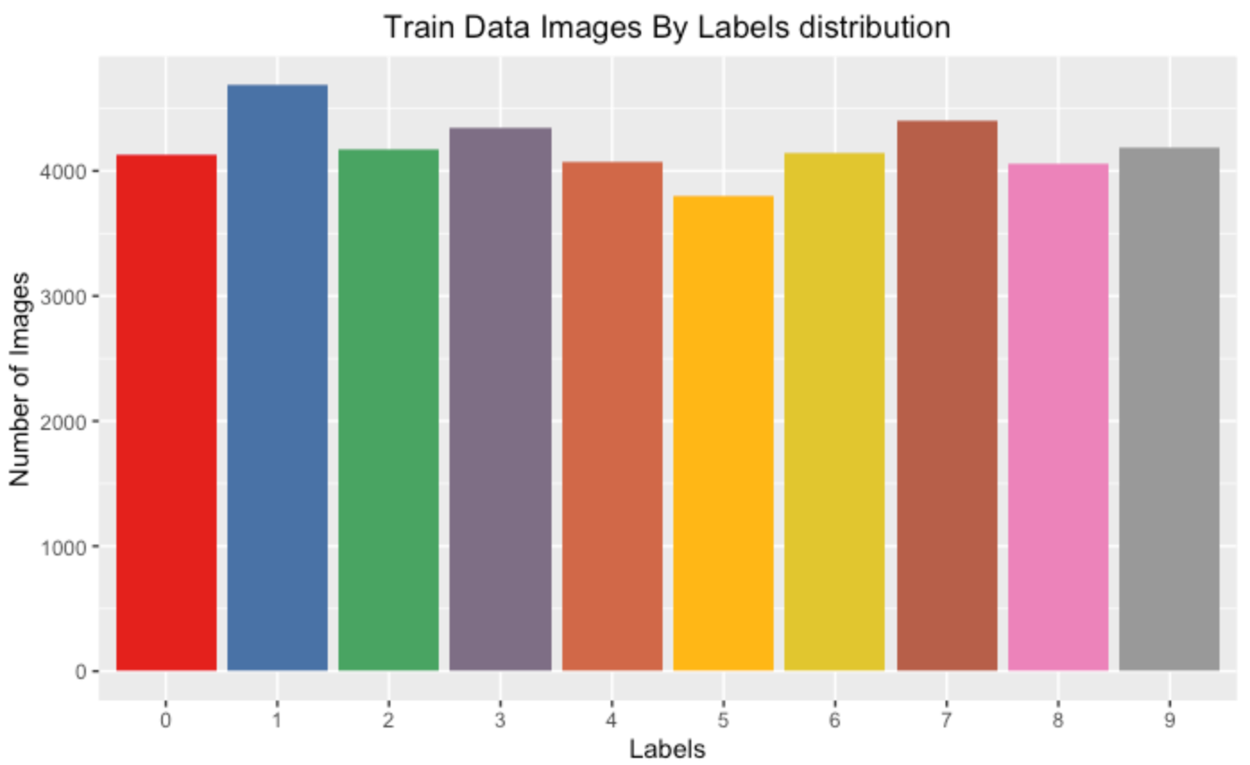

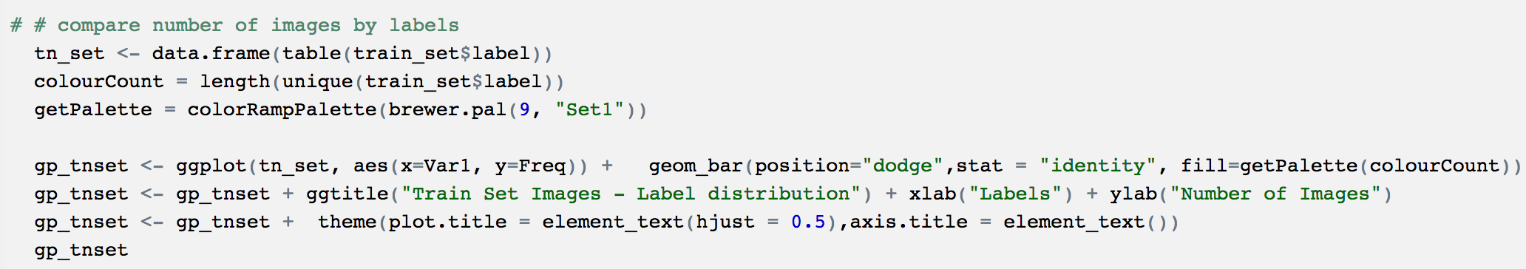

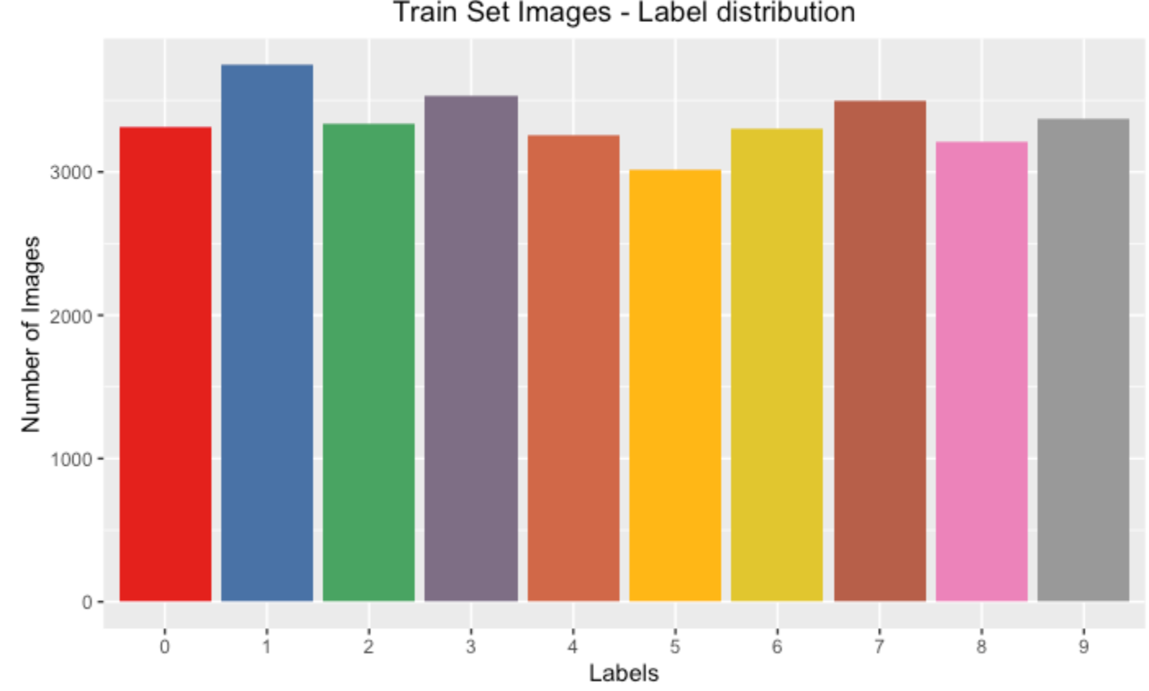

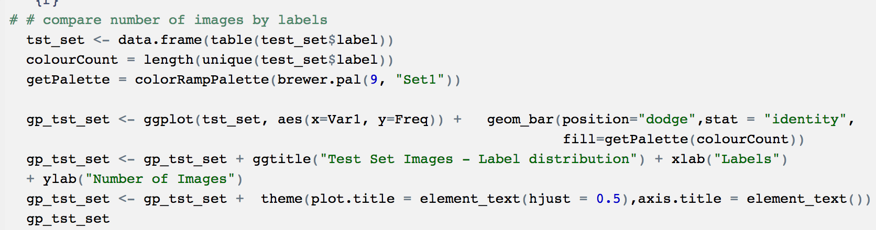

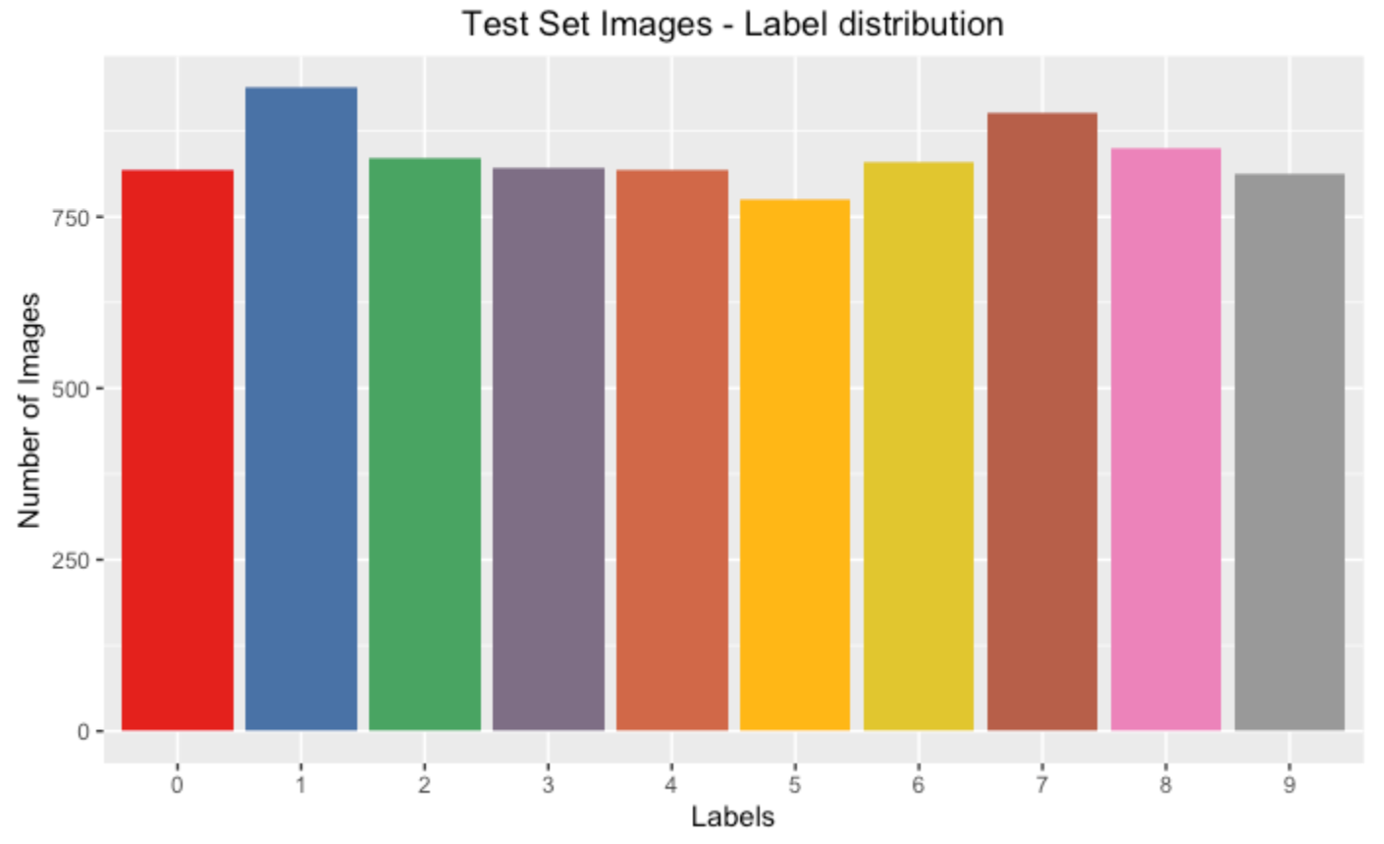

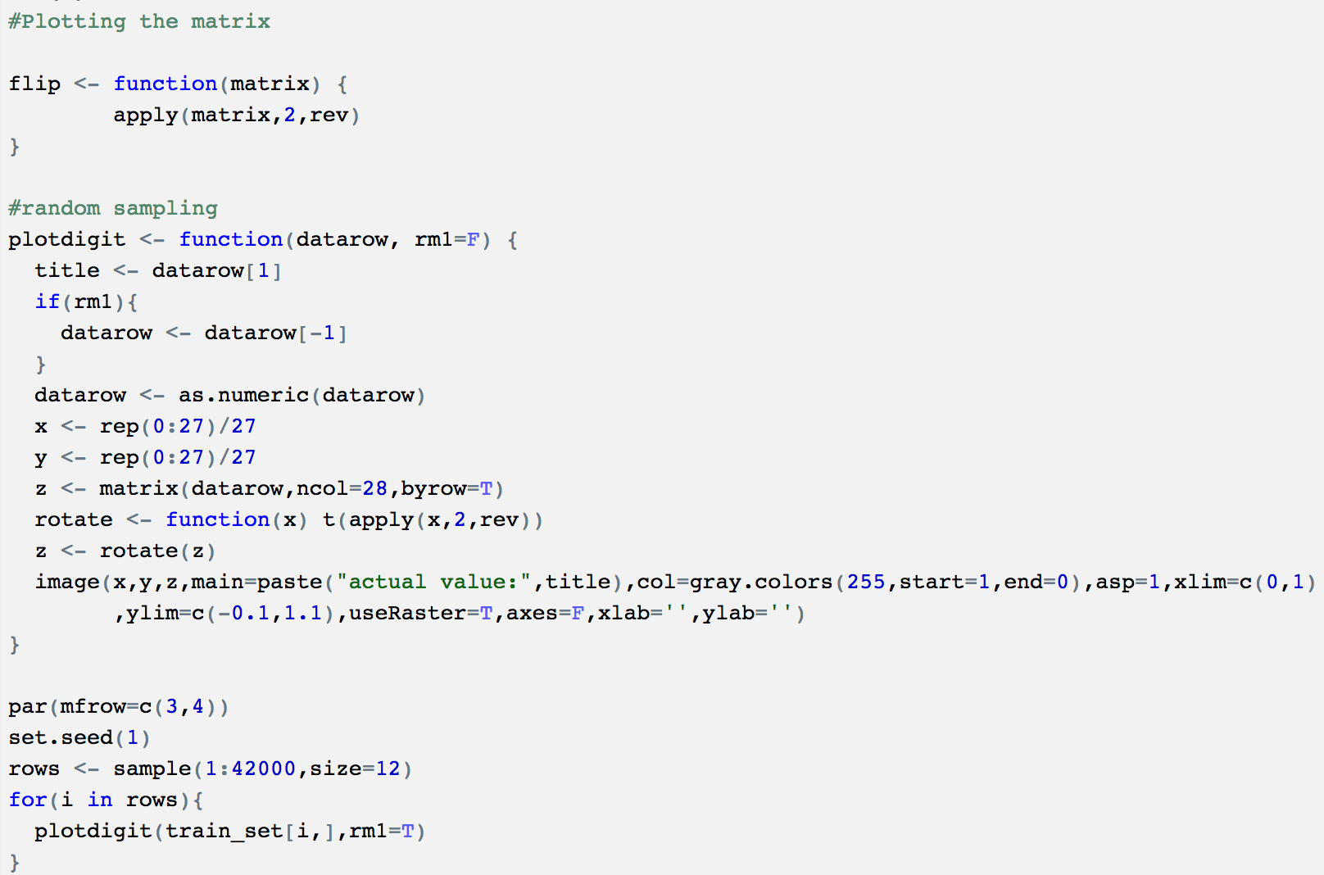

Let’s peek at the actual images from the dataset

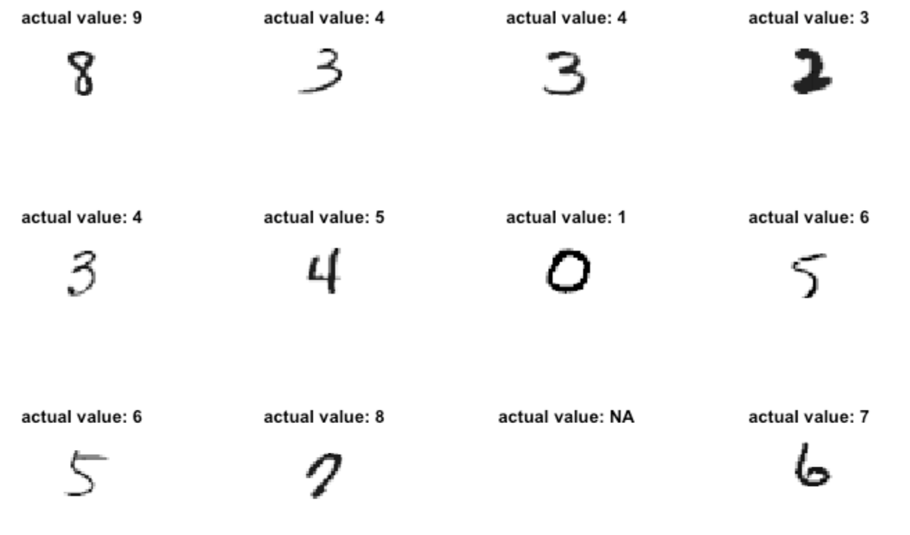

Import the validation file into a dataframe as well. Adding an empty label column for consistency

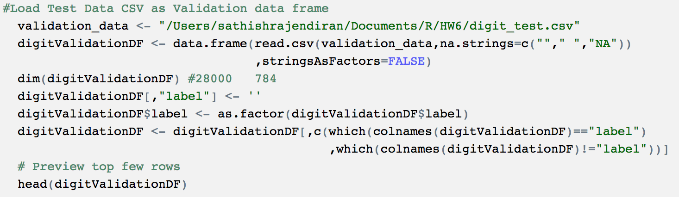

* 1. Principal Component Analysis (PCA)

As the predictor variables are more – it would be wiser to look at other options such as dimensionality reduction to improve the model performance. Principal component analysis help reduce number of dimensions to optimize the model efficiency. In this case, reduce the predictor variable to 30 and rename the columns.

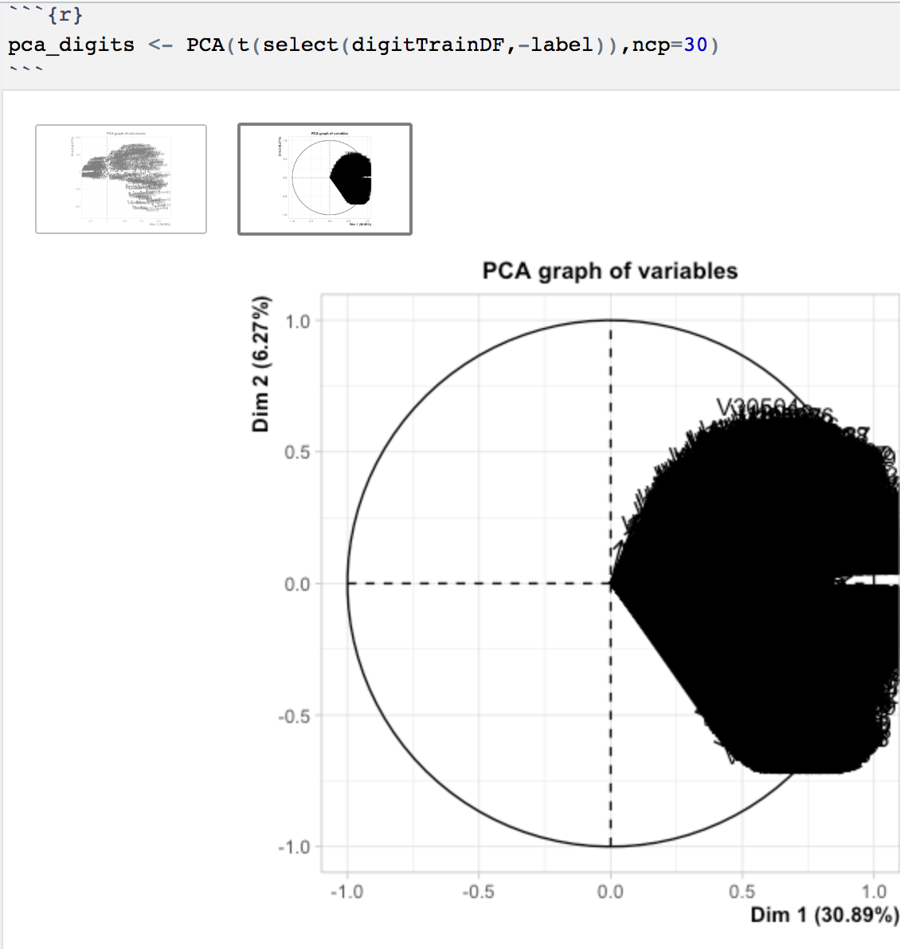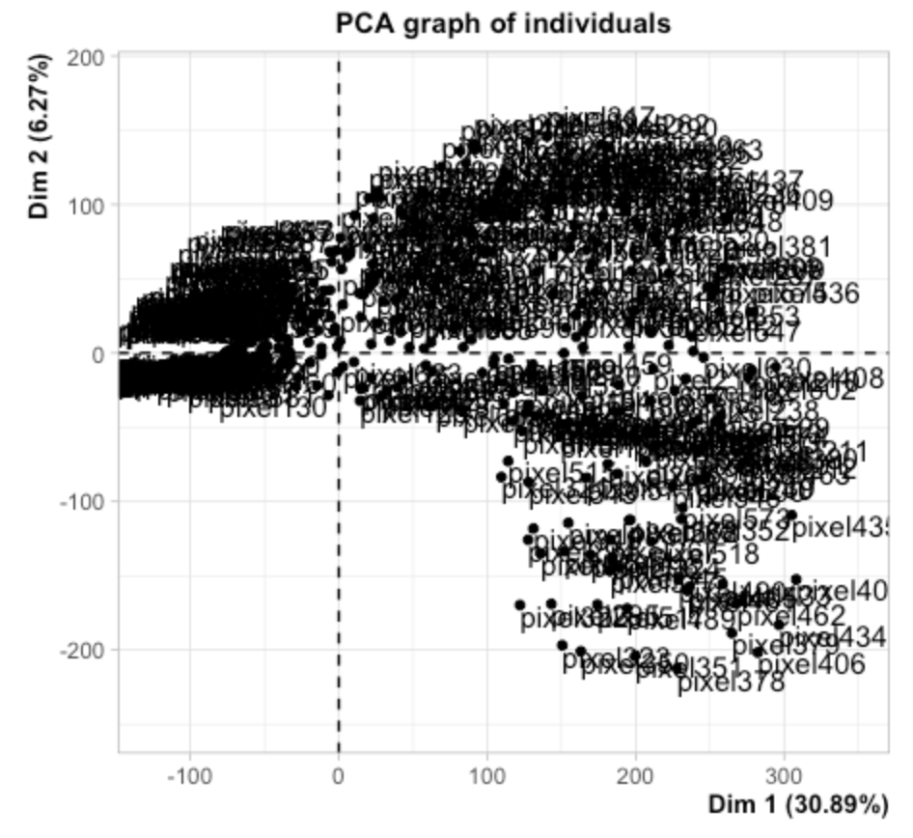



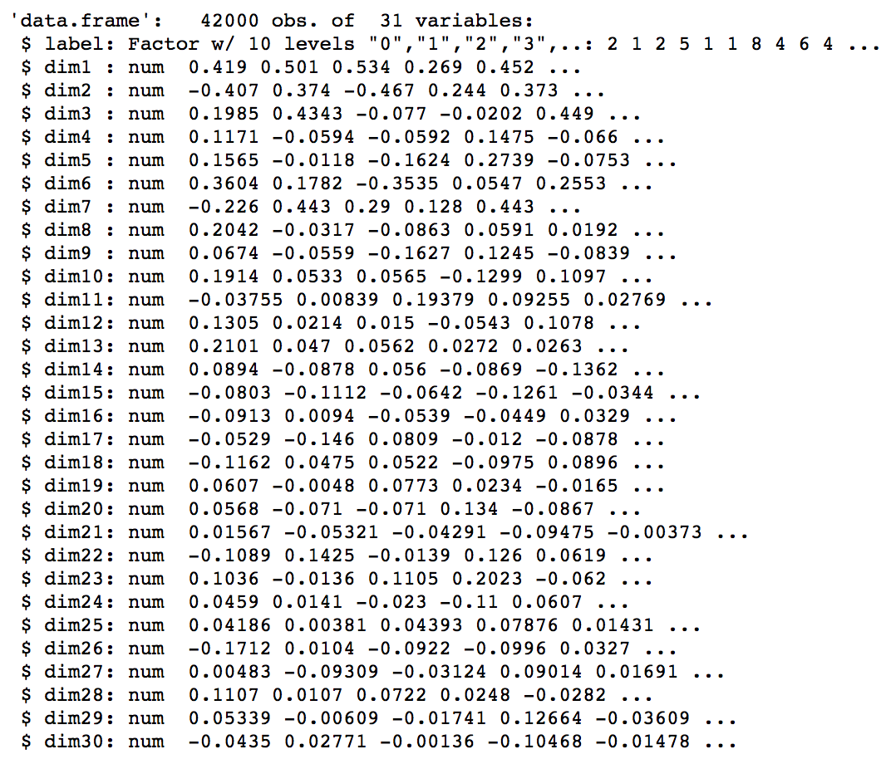

next step is to prepare train and test data set based on the PCA dataset.

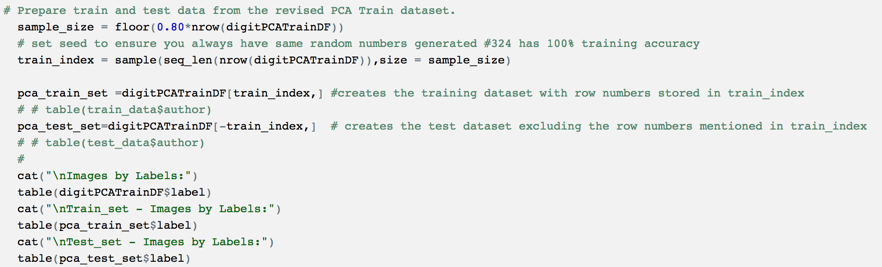

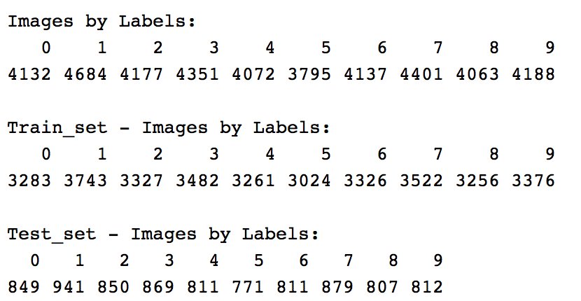

## **Decision Trees (DT)**

Next step is to build and tune machine learning models.

1. Build DT model with control measures (cp, minsplit and maxdepth)

rpart library – from R Studio is used for building the decision trees. Initial case let’s use the original data set split with 784 predictor variables and parameters (cp=0, minsplit=1 and maxdepth=5). This process involves, building the tree, plot and summarize it with cross validation results.

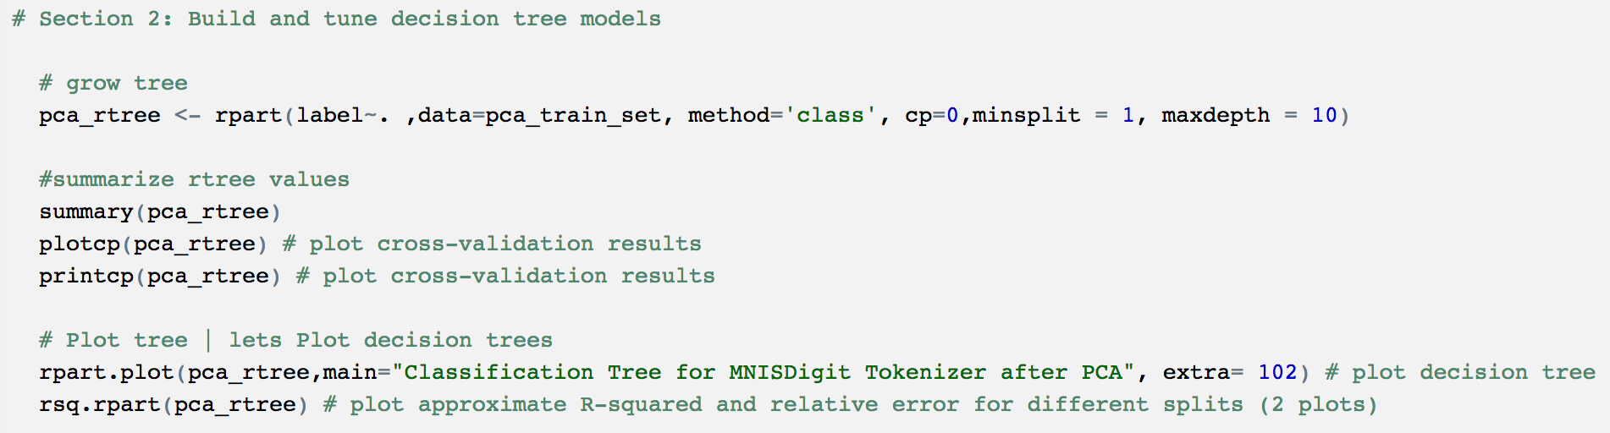

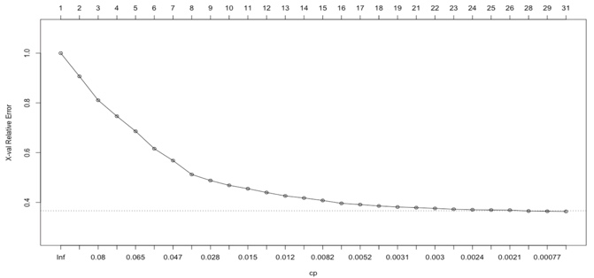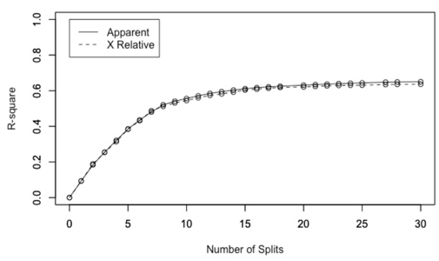

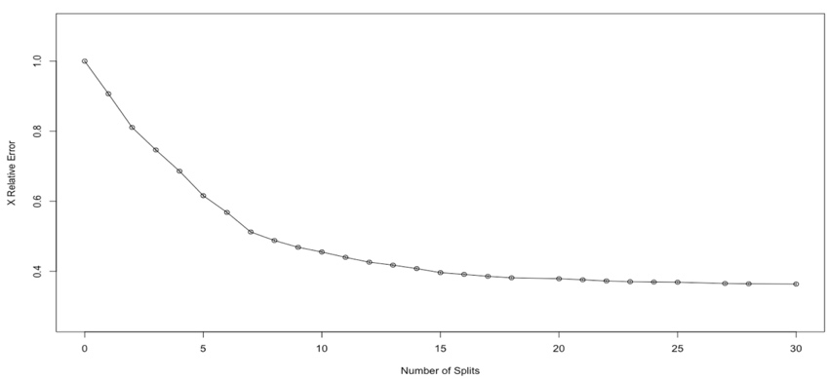

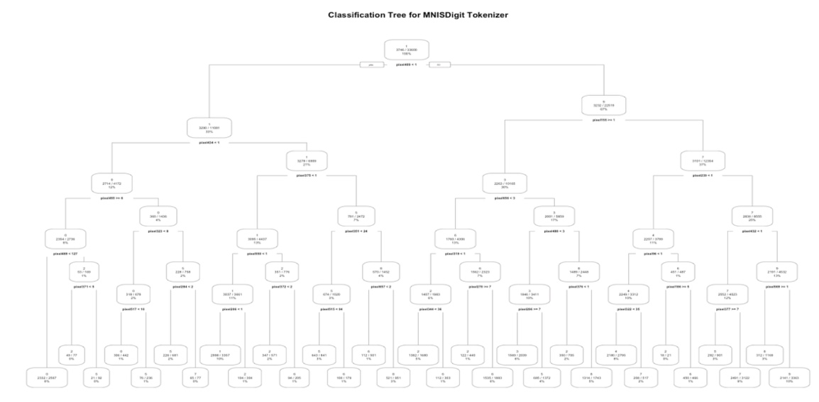

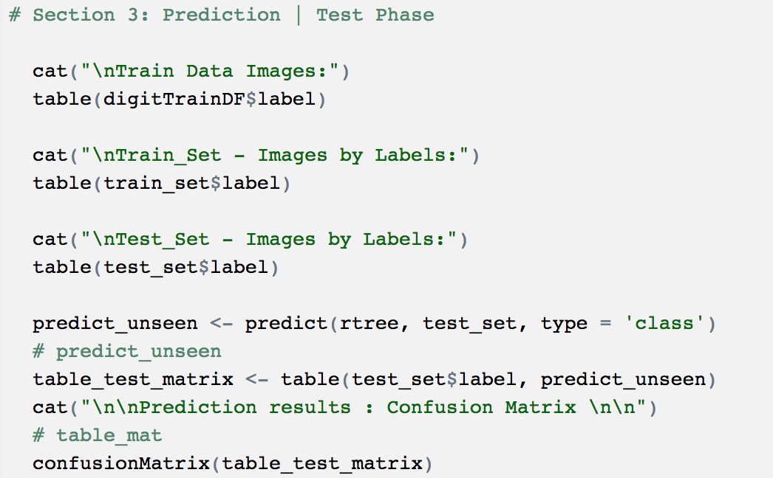

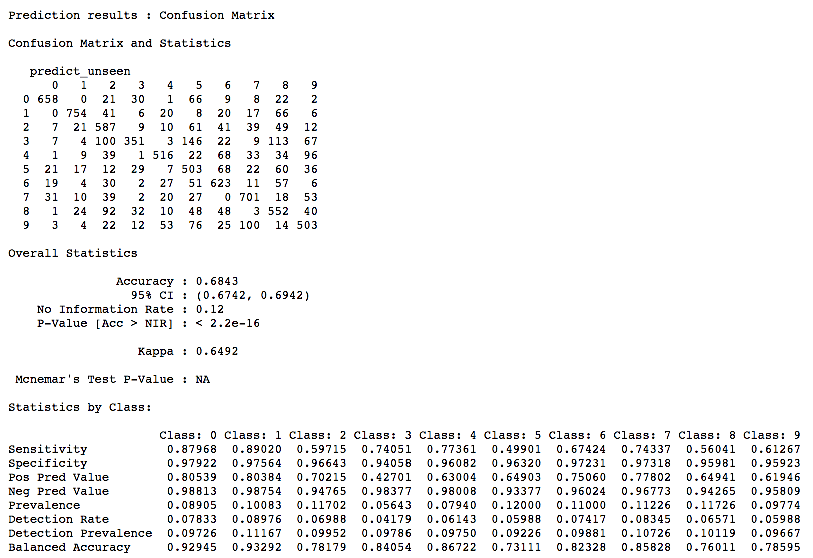

From above, Decision tree with original dataset - Accuracy is at 68.43%

1. Tune Decision tree model with PCA & control measures (cp, minsplit and maxdepth)

Let’s build the tree but with train set prepared through PCA. i.e. with 30 predictor variables and analyze the model performance

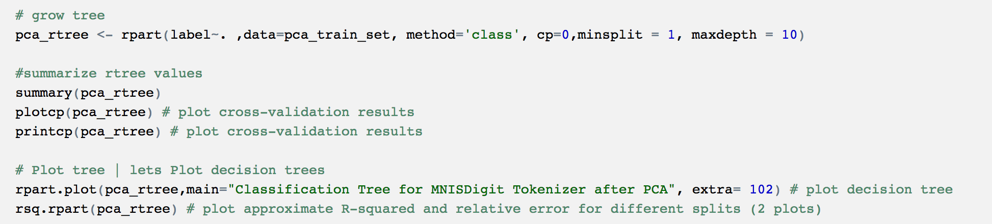

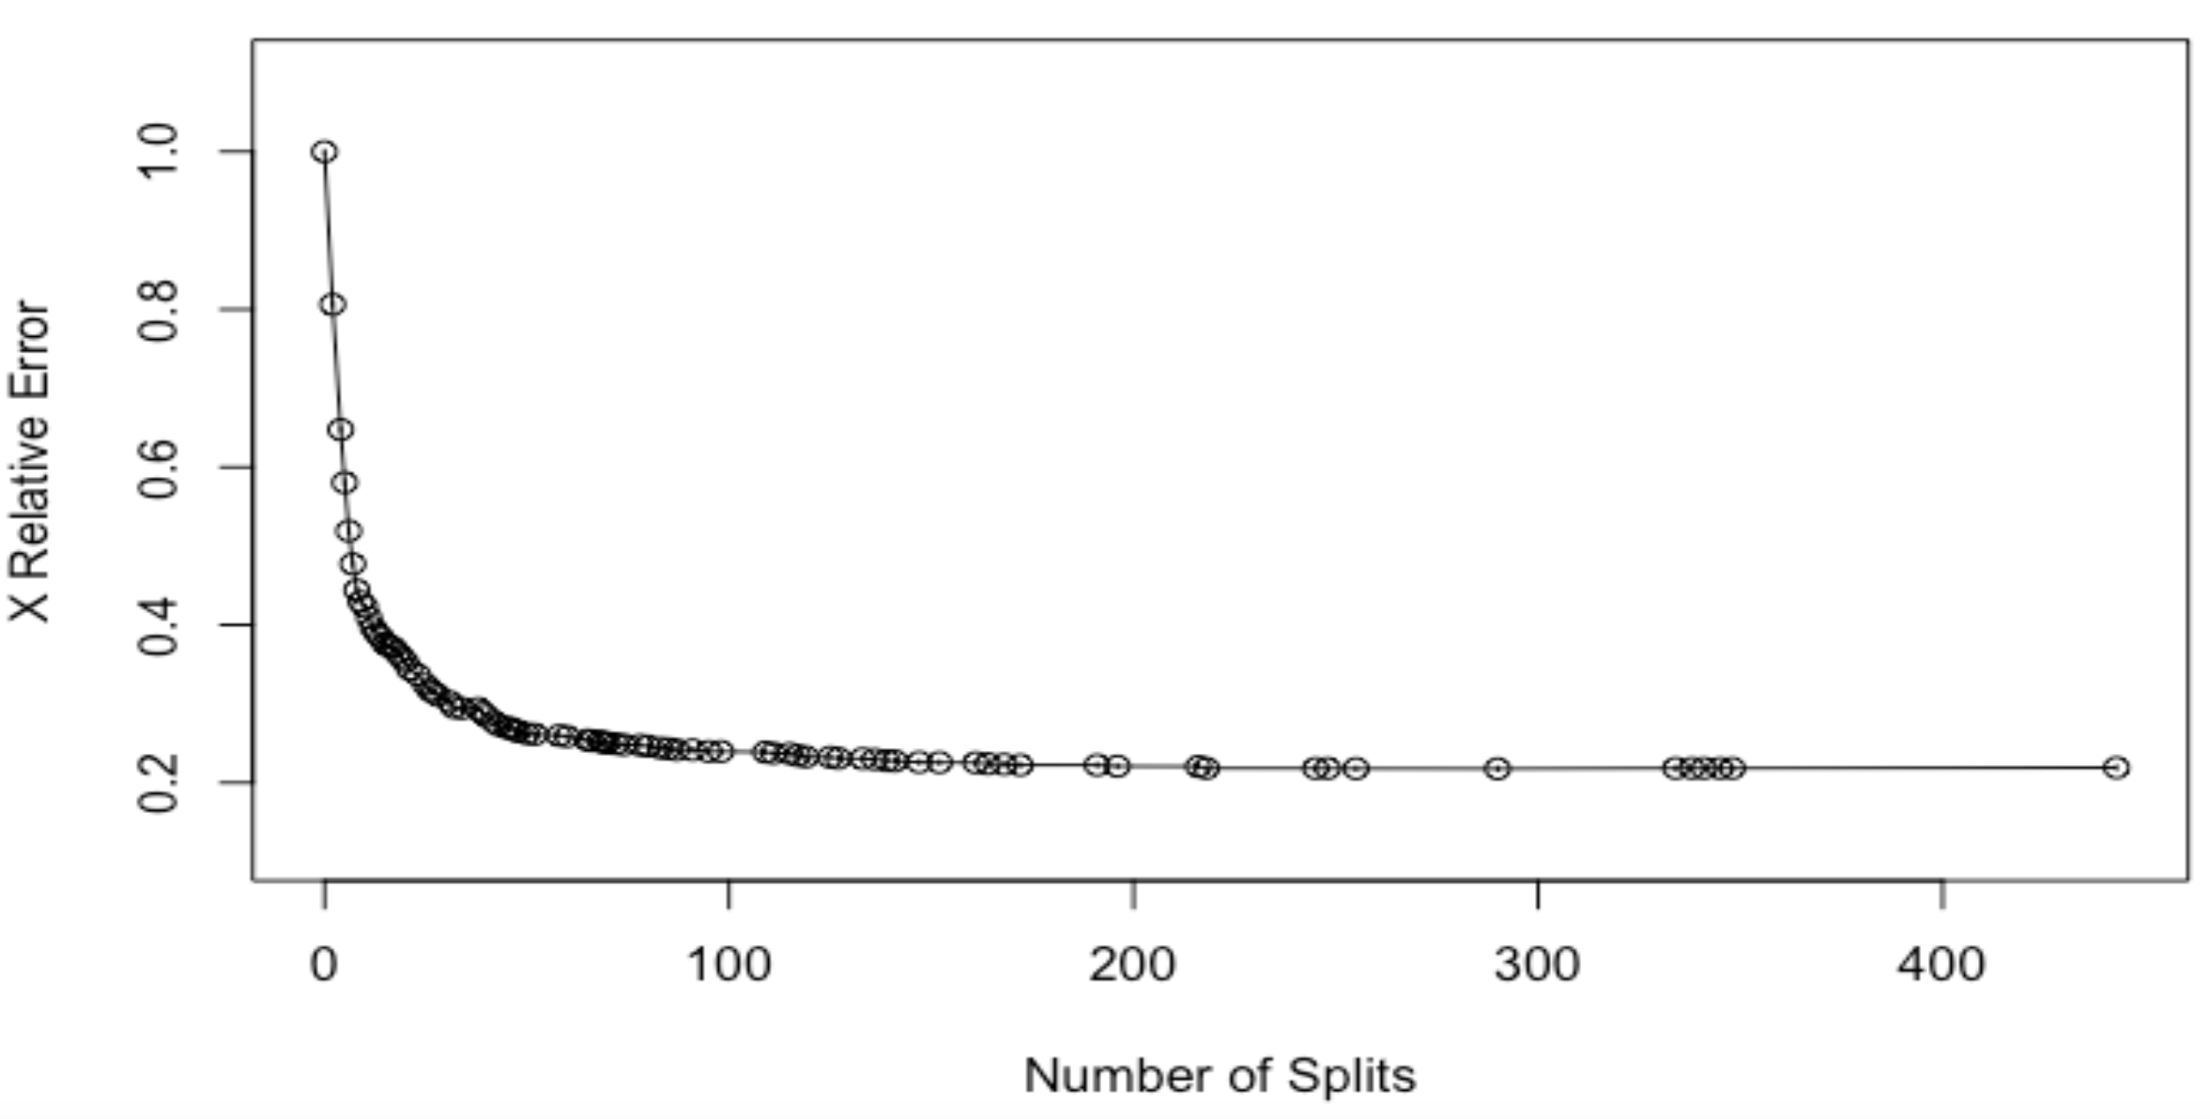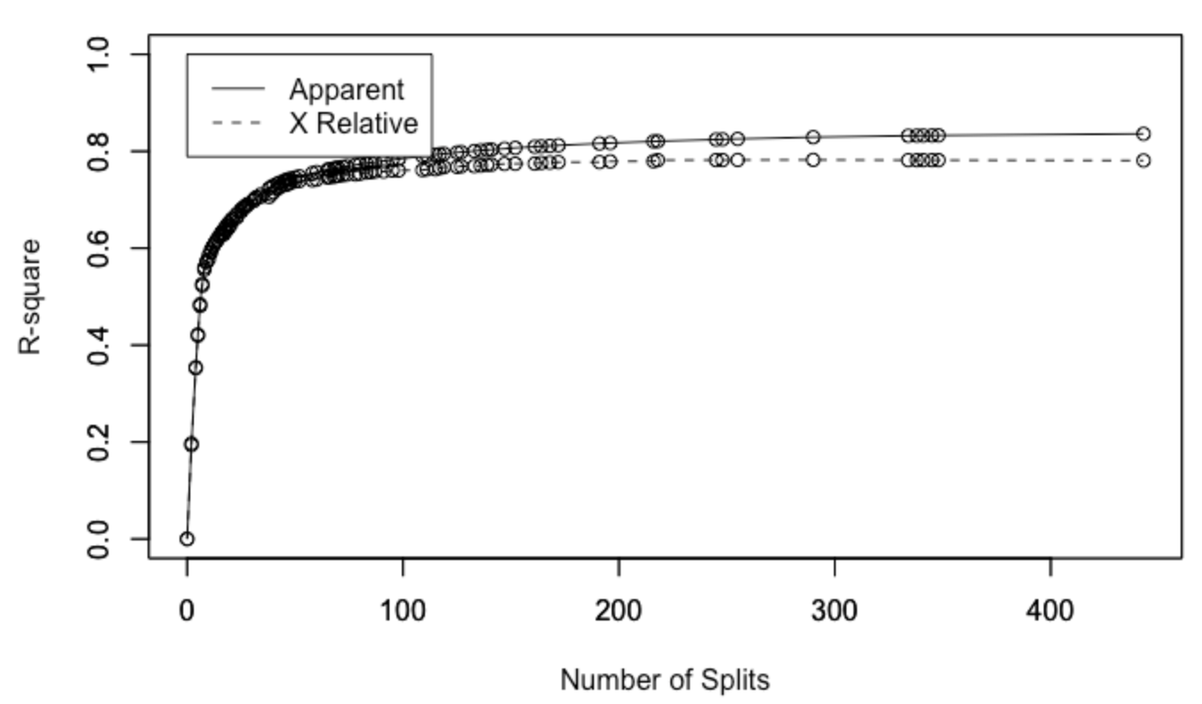

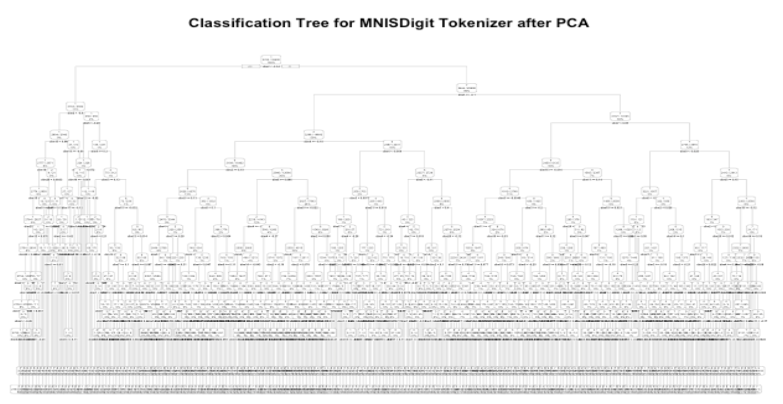

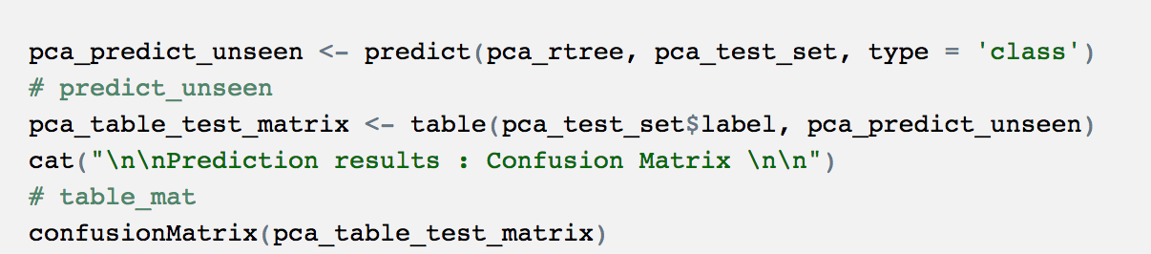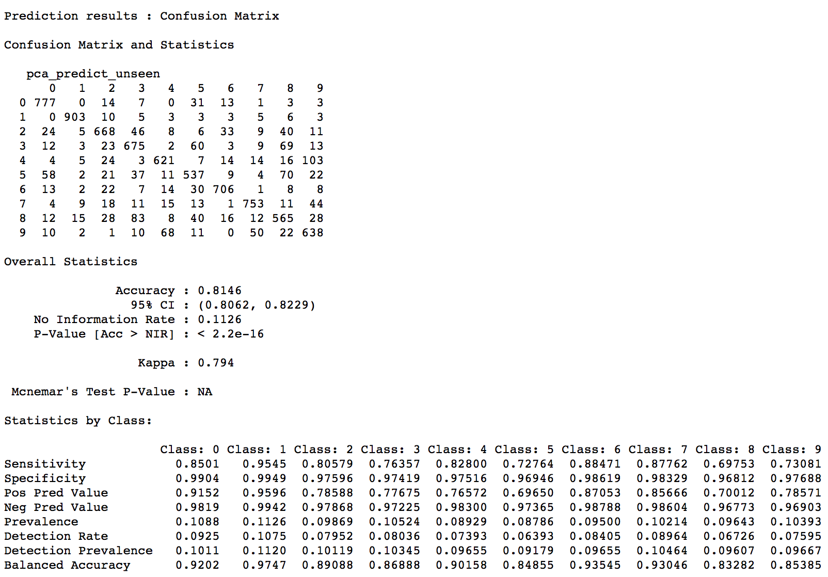

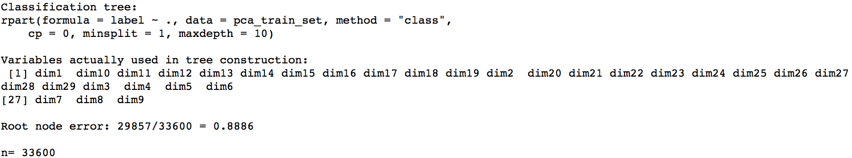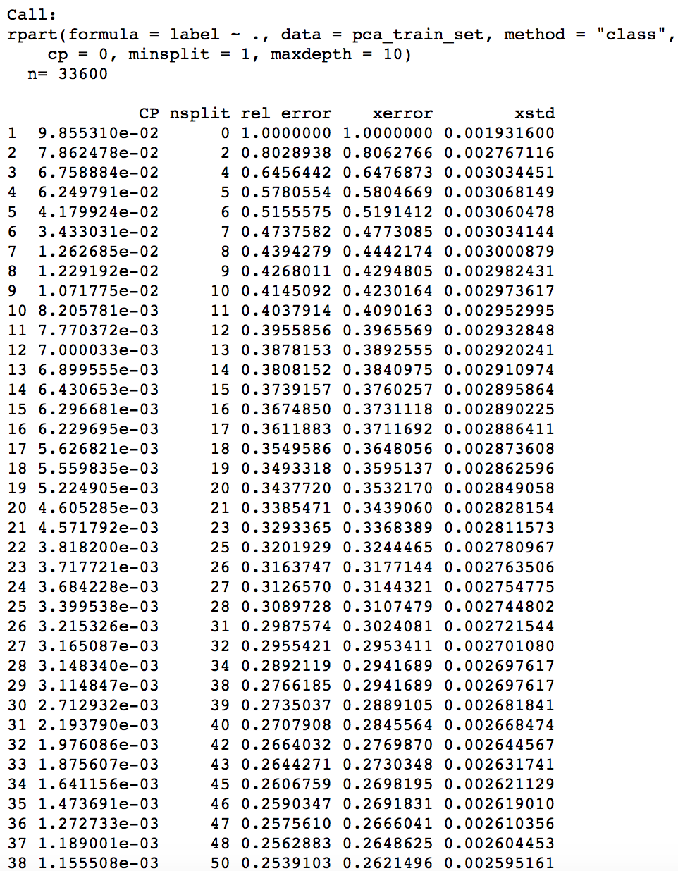

Prepare the output file for kaggle

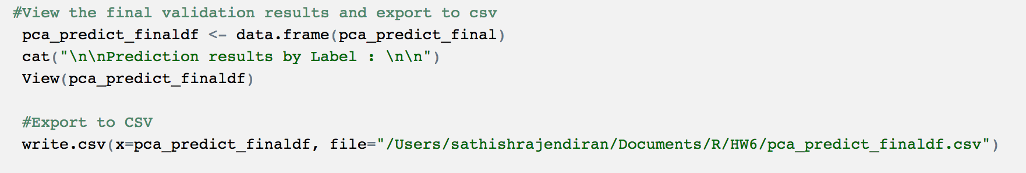

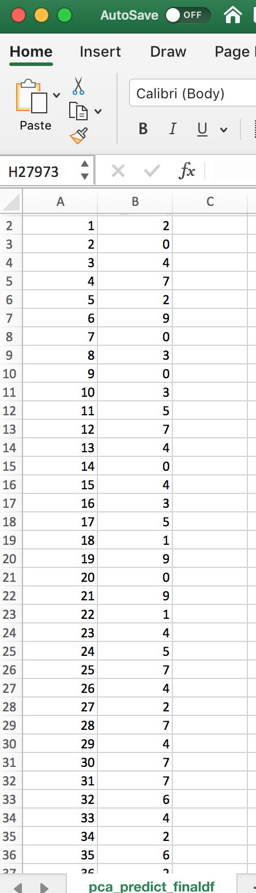 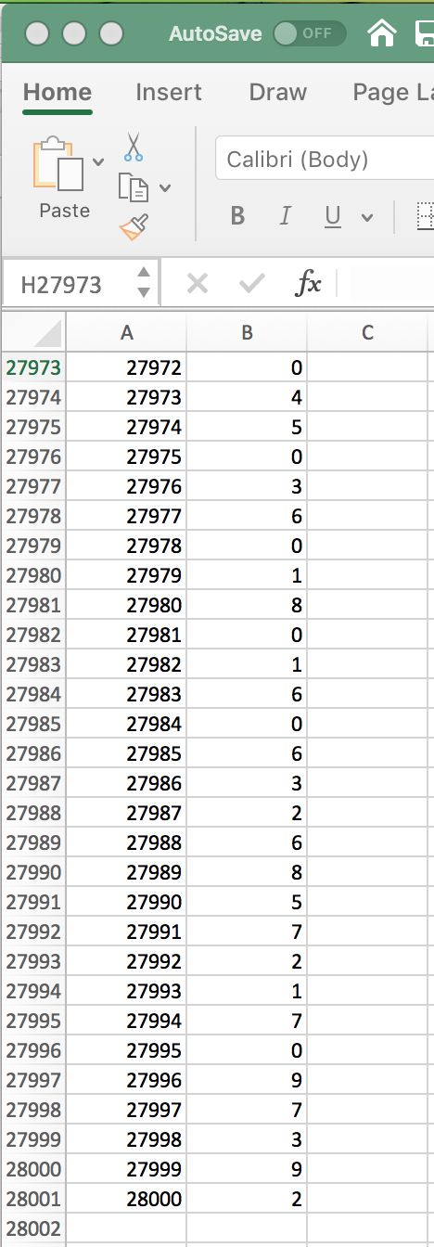

From above, Decision tree on PCA dataset with control measures (cp=0, minsplit=1 and maxdepth=10) - Accuracy is at 81.46%

## **Supply Vector Machine (SVM)**

* SVM model on the PCA dataset with “linear” kernel and cost factor at 10

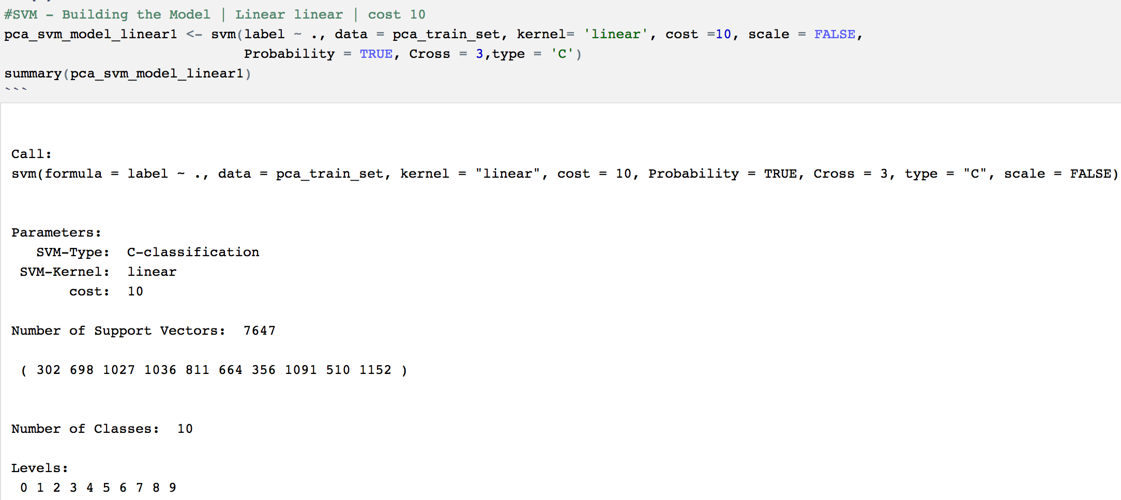

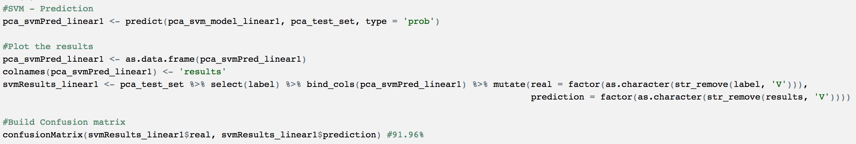

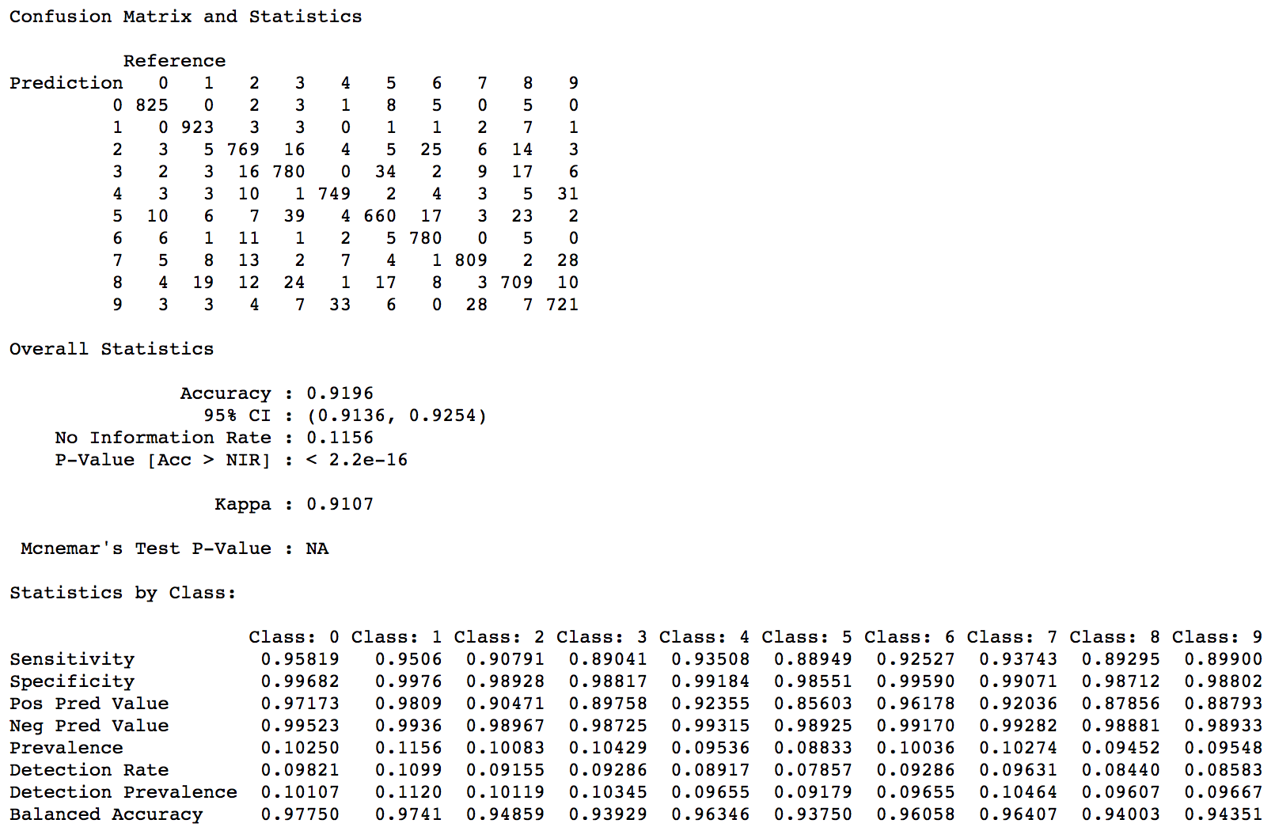

From above, SVM model on PCA dataset with control measures (cost = 10, kernel=” linear”) - Accuracy is at 91.96%. Better than either of decision tree models.

* SVM model on the PCA dataset with “polynomial” kernel and cost factor at 100

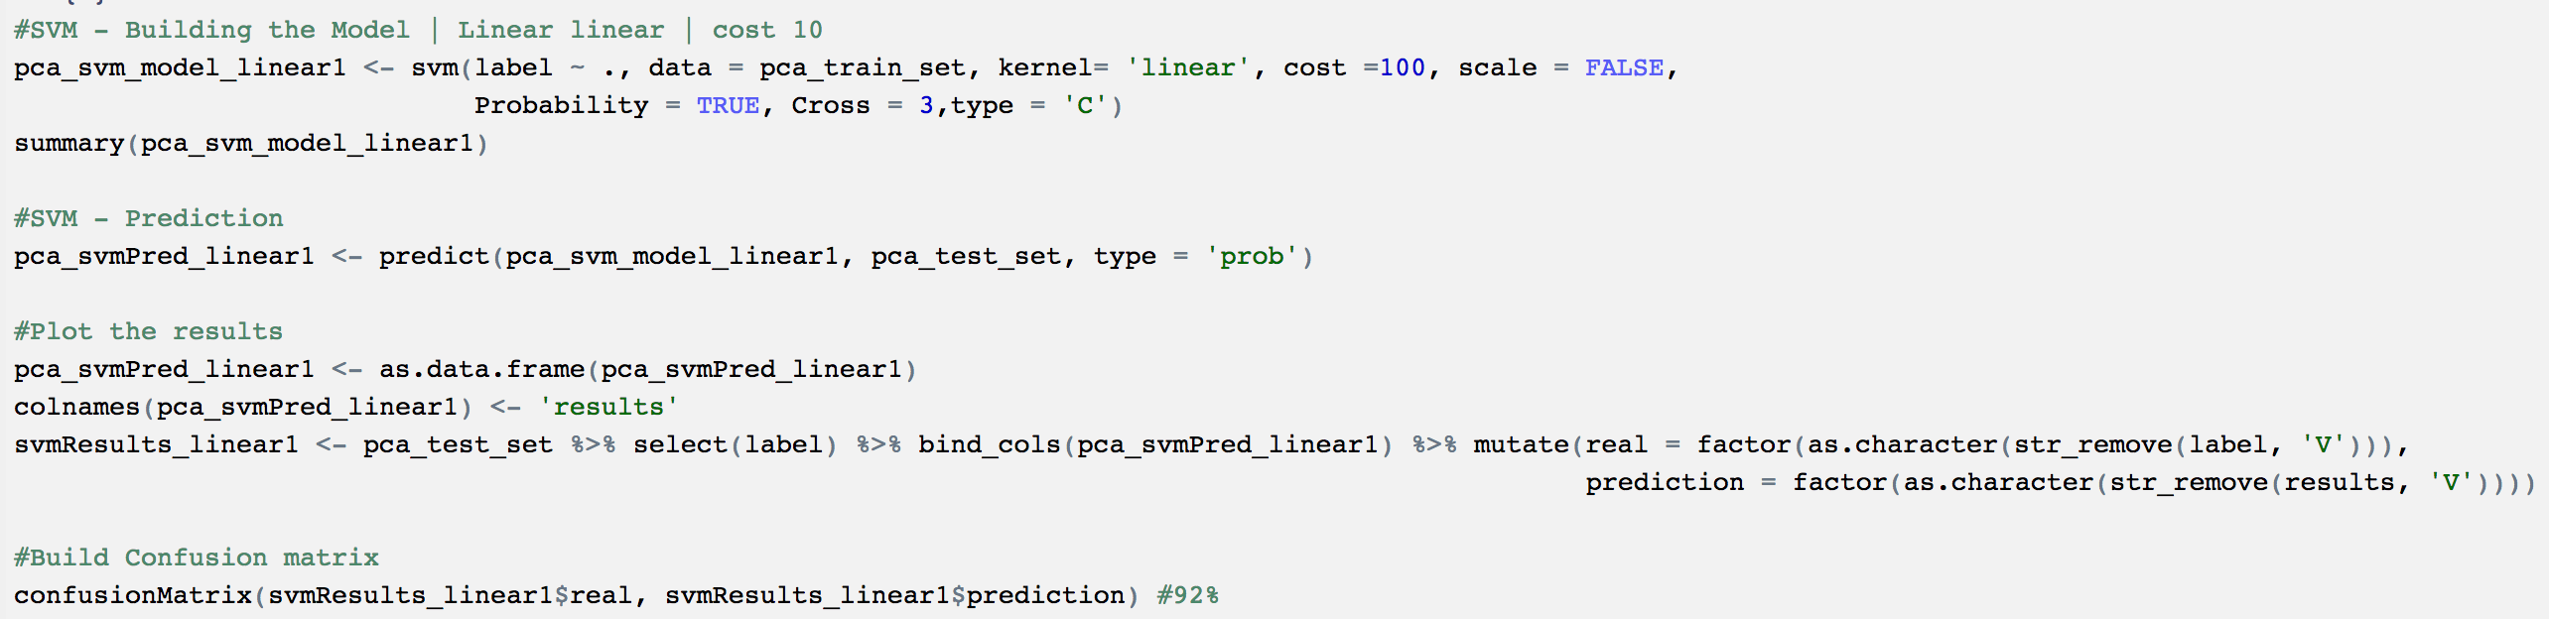

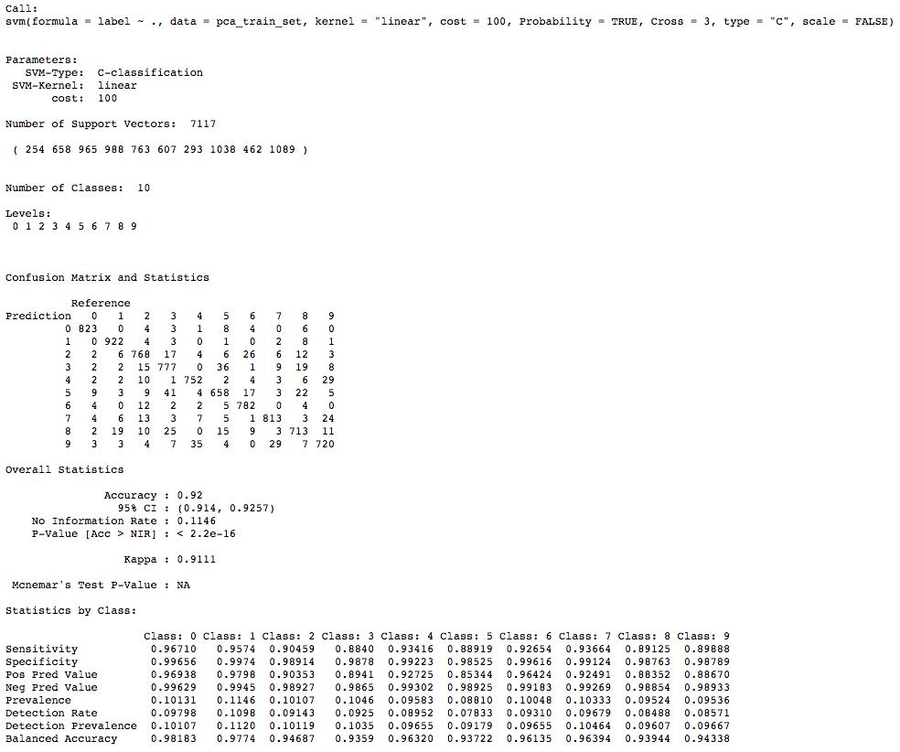

From above, SVM model on PCA dataset with control measures (cost = 100, kernel=” polynomial”) - Accuracy is at 92%. Better than either of decision tree models, slightly better than SVM linear model

* SVM model on the PCA dataset with “radial” kernel and cost factor at 100

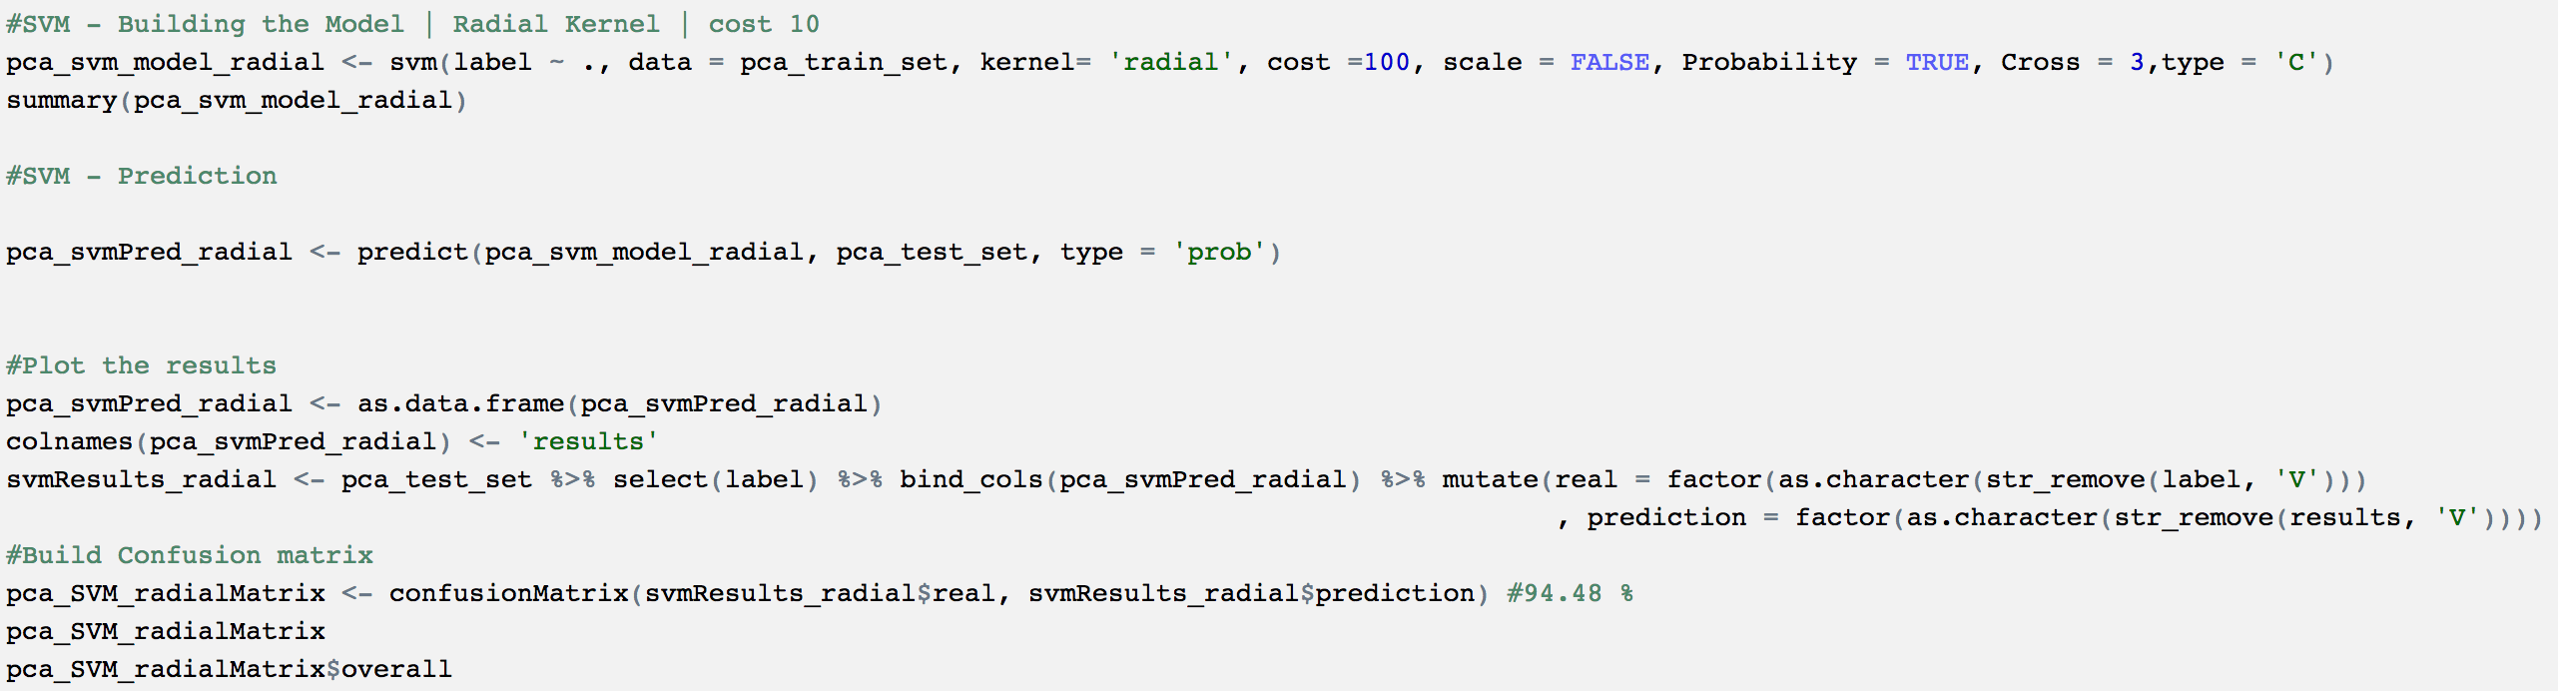

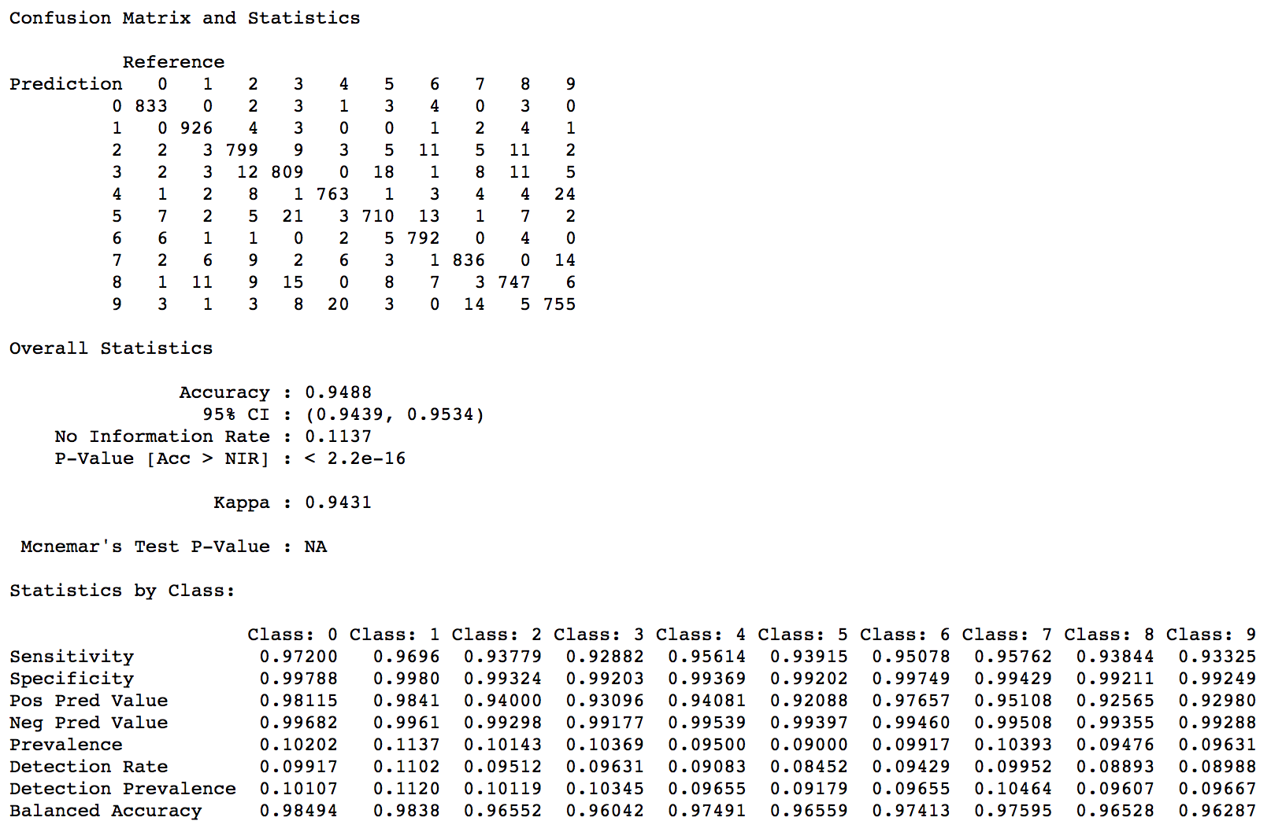

From above, SVM model on PCA dataset with control measures (cost = 100, kernel=” radial”) - Accuracy is at 94.88%. Better than either of decision tree models, SVM linear & polynomial models.

## 

## **Naïve Bayes**

**

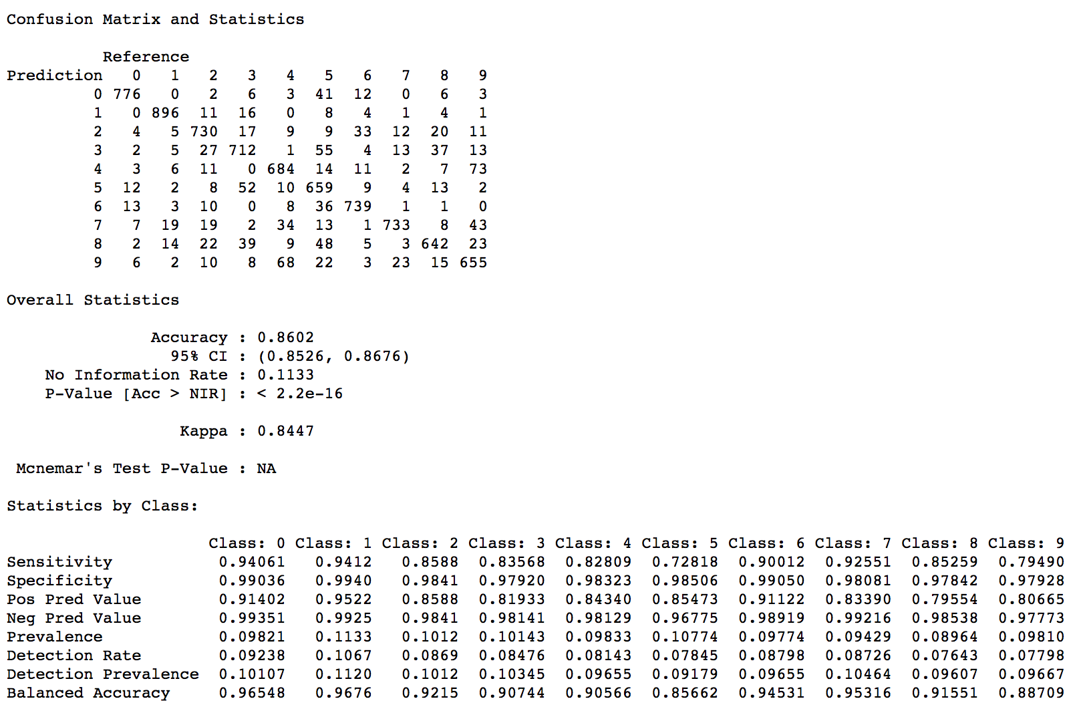

From above, Naïve bayes model on PCA dataset with control measures (cost = 100, type=” C”) - Accuracy is at 86.02%. Better than either of decision tree models; However, not as good as other two SVM models.

## **k-Nearest Neighbors (kNN)**

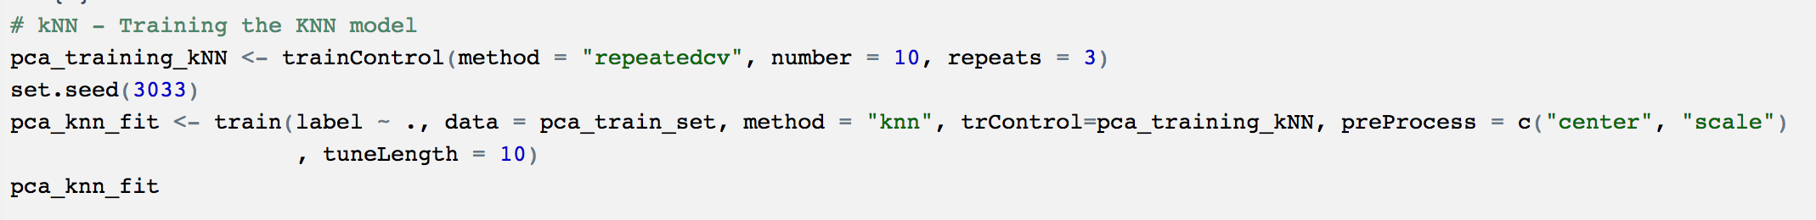

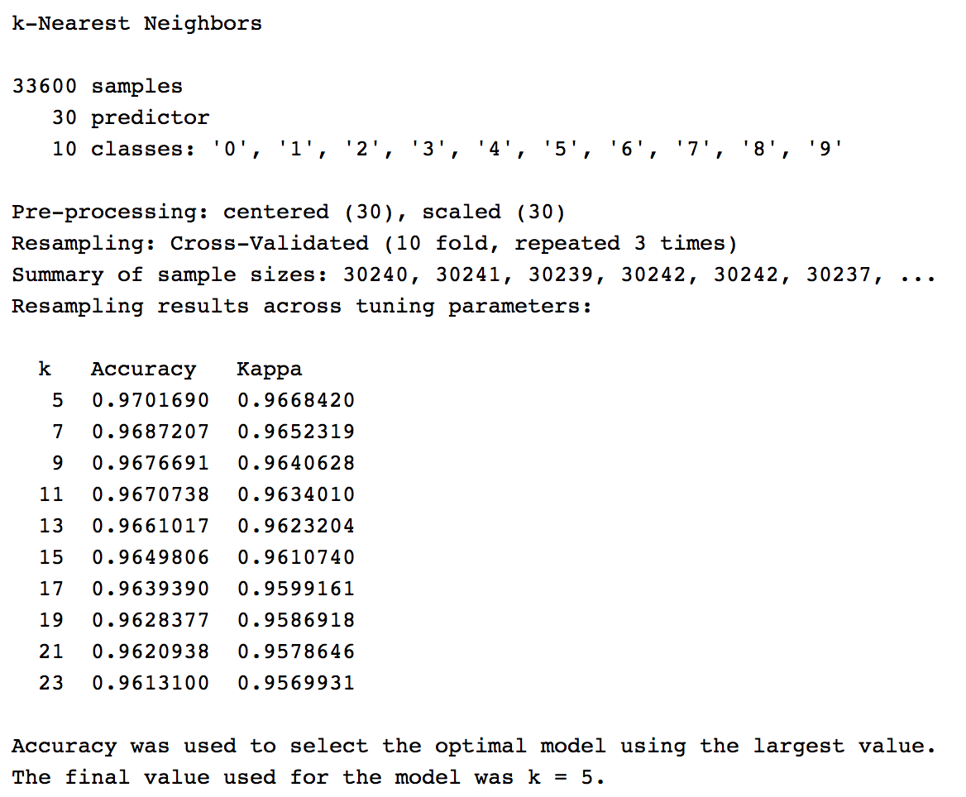

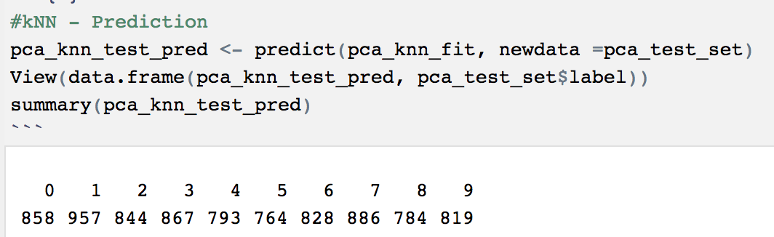

From above, kNN model on PCA dataset with control measures (repeats = 3 and k= 5) Accuracy is at 97.01%. Better than either of decision tree, all the SVM models.

## **Random Forest**

**

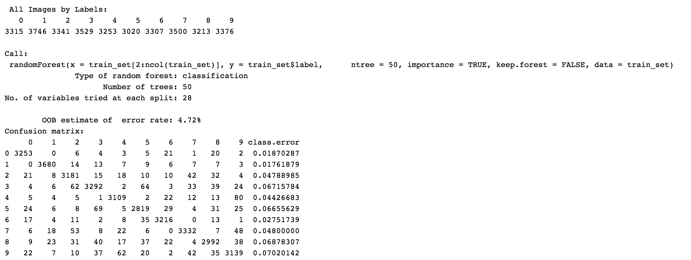

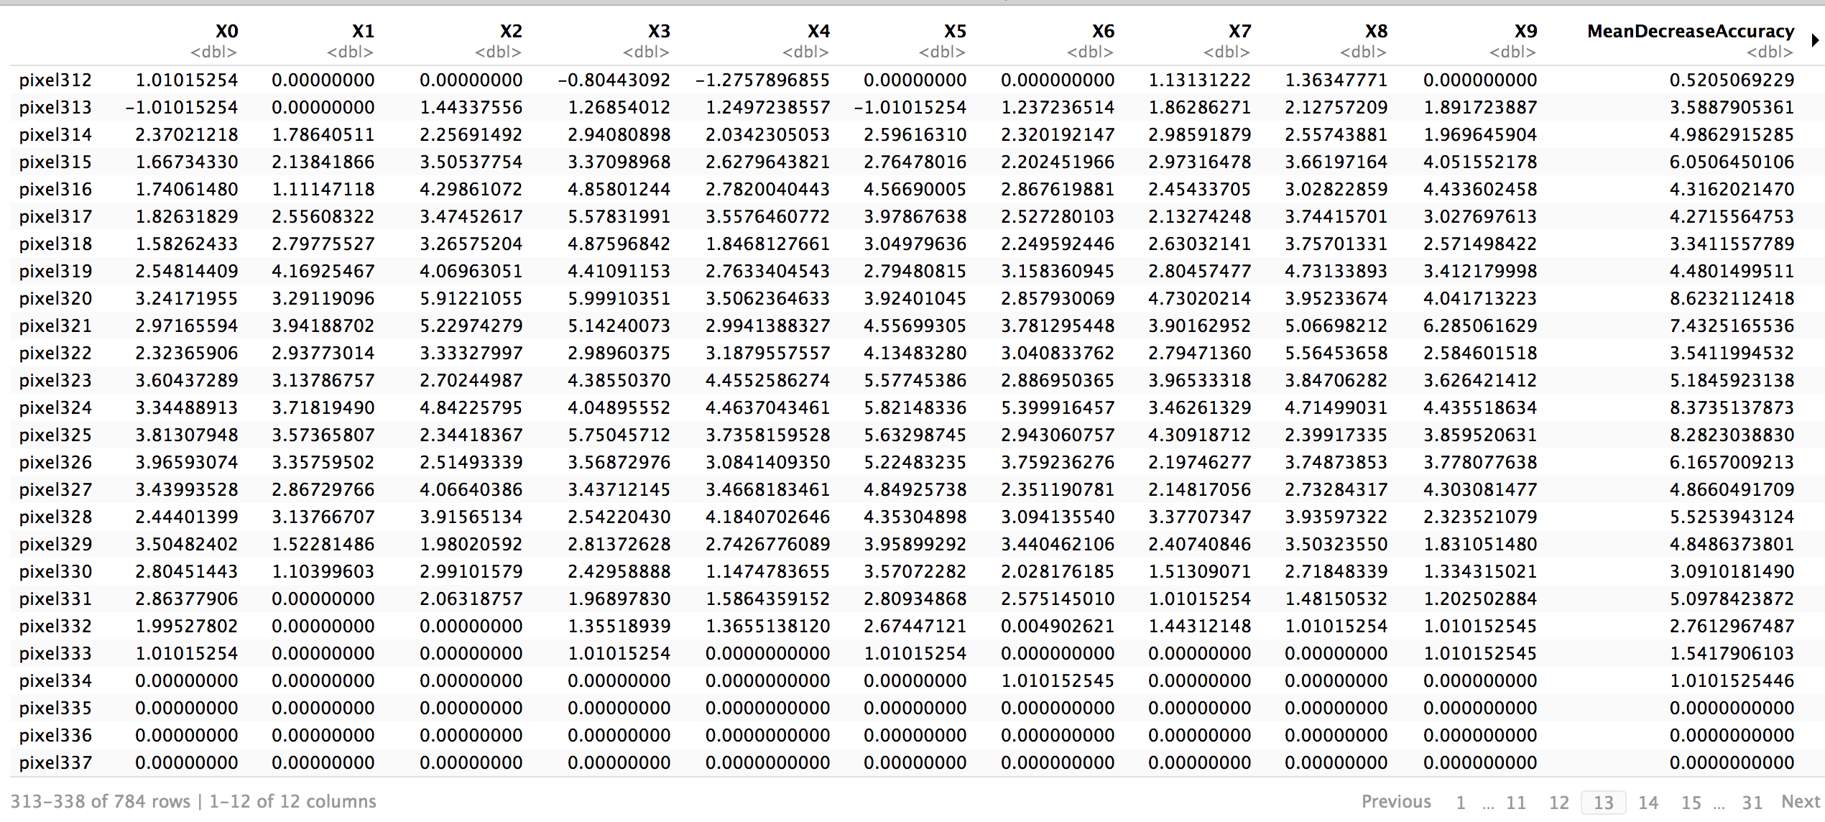

From above, Random forest model on actual train dataset with control measures (ntrees=50) had an accuracy is at 95.28%. Better than decision tree, all the SVM models, and naïve bayes models.

## **Summary**

* Based on above analysis
  + dimensionality reduction –number of predictor variables were reduced to 30 with principal component analysis.
  + Decision Tree models – decision tree with actual train and test data sets yielded an accuracy of 68.43%; Whereas, with PCA dataset the accuracy has increased to 81.46%
  + Supply Vector Machine (SVM) models– 3 versions of SVM model built on PCA dataset had slightly better results than DT models. SVM with linear Kernel performed better than DT models at 91.06% accuracy followed by SVM (polynomial – kernel) with 92% and SVM (radial -kernel) at 94.88% accuracy results.
  + k-Nearest Neighbors (KNN) – on PCA dataset had better results at k value 5 as 97.01%.
  + Naïve Bayes – This model predicted at 86.02% with PCA dataset
  + Random Forest model predicted with 95.28% on the actual dataset with number of trees set as 50

## **Conclusion**

In comparison with all the classification models, PCA really helped drive the values much better by reducing the dimensions from 784 to 30 keeping pixels only had impact on the image classification.

“Overall all the models preformed significantly over 80% accuracy with kNN (k =5) emerging as the winner with 97.01% followed by Random Forest with 95.28% accuracy and SVM (kernel=” radial”) at 94.88% accuracy.

Very good exercise to understand the behavior of various classification models and to highlight the significance of dimensionality reduction when dealing with huge predictor set.